EXPERIMENT 4

AIM : To write an assemble language program to implement 8 bit division using 8085 processor.

ALGORITHM:

* Start the program by loading the HL pair registers with address of memory location.
* Move the data to B Register.
* Load the second data into accumulator.
* Compare the two numbers to check carry.
* Subtract two numbers.
* Increment the value of carry.
* Check whether the repeated subtraction is over.
* the program by loading the HL pair registers with address of memory location.
* Move the data to B Register.

PRORAM:

LDA 8501

MOV B,A

LDA 8500

MVI C,00

LOOP: CMP B

JC LOOP 1

SUB B

INR C

JMP LOOP

LOOP1: STA 8502

MOV A,C

STA 8503

RST 1

INPUT:

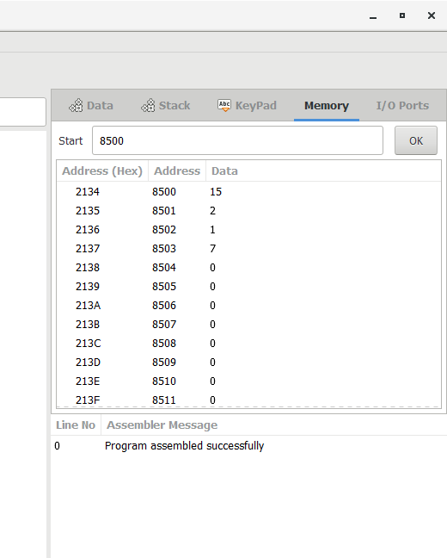

OUTPUT

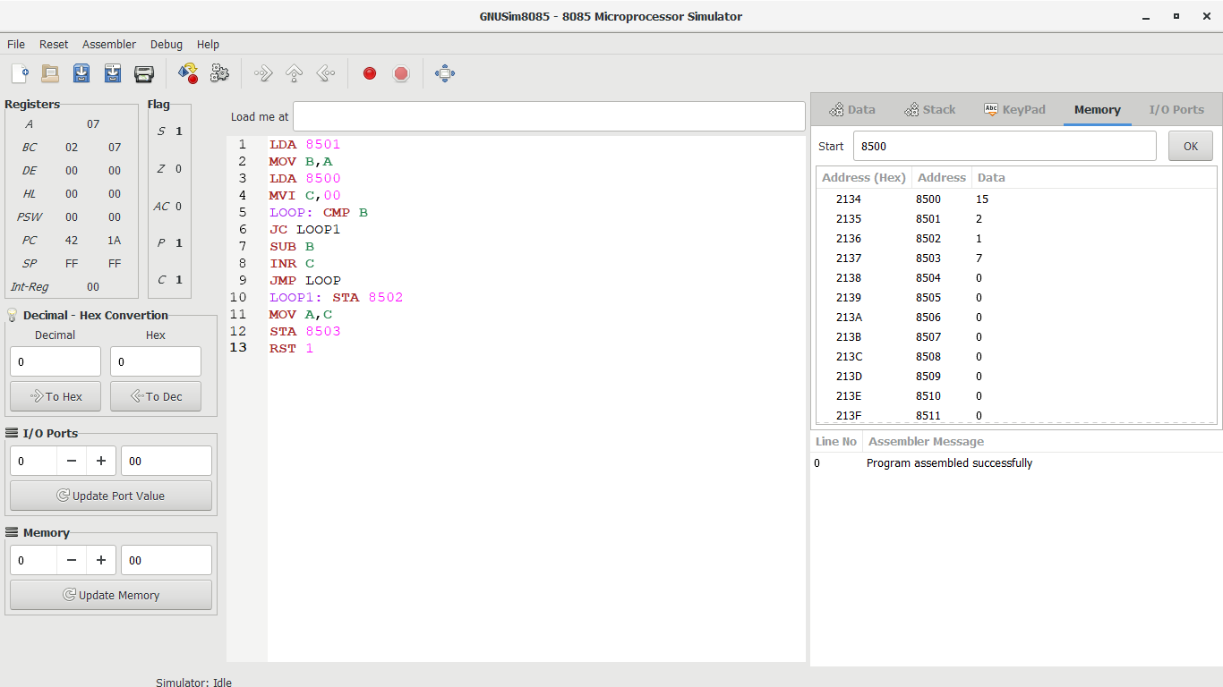

RESULT

Thus the program was executed successfully using 8085 processor simulator.